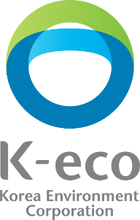
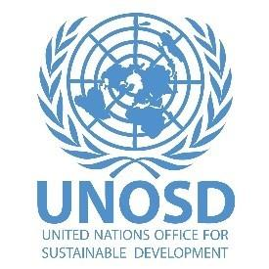
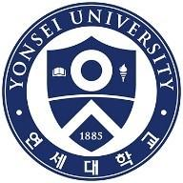

4th Sustainable Development Goals Youth Summer Camp
10-13 August 2020 - Incheon, Republic of Korea
Organized by the United Nations Office for Sustainable Development (UNOSD) of the UN Department of Economic and Social Affairs (UN DESA), and the Korea Environment Corporation (K-eco) in partnership with Yonsei University

- Rationale
Today, there are 1.8 billion people between the ages of 10-24—they are the largest generation of youth in history (UN, 2019) With nearly 90 per cent of youth live in developing countries, and these numbers are expected to grow—between 2015 and 2030 alone, about 1.9 billion young people are projected to turn 15 years old yet youth are not leading the implementation of the 2030 Agenda as they should be (UN, 2019)

Since the adoption of 17 Sustainable Development Goals (SDGs) of the 2030 Agenda for Sustainable Development in September 2015, UN Member States have been taking voluntary actions to achieve this transformative agenda. However, the rate of global progress is not keeping pace with the aspirations of member states, and societies are still confronted with daunting challenges such as climate change, inequality, environmental degradation, energy crises, lack of or weak public services and most recently, a global pandemic that has threatened to delay progress on the Global Goals. To tackle these problems, it is imperative for stakeholders at all levels to accelerate collective initiatives and actions. But one stakeholder – today’s youth is of primary importance in in forging the leadership, ideas, energy and hope to demand change and build constructive solutions to these challenges.
“The natural environment is deteriorating at an alarming rate: sea levels are rising; ocean acidification is accelerating; the last four years have been the warmest on record; one million plant and animal species are at risk of extinction, and land degradation continues unchecked.”
“let us harness the ideas and energy and sense of hope of young people —in particular young women — demanding change and constructive solutions.”
- UN Secretary-General António Guterres^{, 3}

Actively engaging youth and shaping their knowledge, skills and mindsets for sustainable development is vital to the successful implementation of the 2030 Agenda in the coming decade. Not least because youth are already becoming political leaders, social and green entrepreneurs and champions of change, but also because they will only increasingly do so in the decades to come. Many leaders today are aware of the power of youth to galvanize change, as seen when a then 15-year old climate activist Greta Thunberg started her #FridaysforFuture movement that has now spread globally.

Acknowledging the role of youth in sustainable development, organizations and governments alike have established strategies to raise youth’s awareness and capacity for the SDGs. For instance, “Youth 2030: The United Nations Youth Strategy” was launched on 24 September 2018 by the UN Secretary-General. It seeks to strengthen and increase commitments from global to national levels to empower youth’s capacity and contributions for the SDGs. The UN has also launched key campaigns to engage youth, such as Be The Change, provides practical ways youth and all citizens can champion how to “walk the talk” when it comes the SDGs, by changing consumption patterns, transport methods, and much more. Lastly, in September 2019, during the UN Secretary-General’s SDG Summit, Heads of State agreed on a Political Declaration committing to a Decade of Action and ten accelerators that include youth throughout (A/RES/74/4).

In this context, UNOSD has developed the capacities of youth on Sustainable Development since the office’s inception nearly a decade ago. With the adoption of the 2030 Agenda for Sustainable Development in 2015, UNOSD began organizing SDG Youth Summer Camps to empower youth leaders to think critically and get engaged in implementing the Goals. Three SDG Youth Summer Camps have been organized with over 150 youth trained thus far.

- Methodology
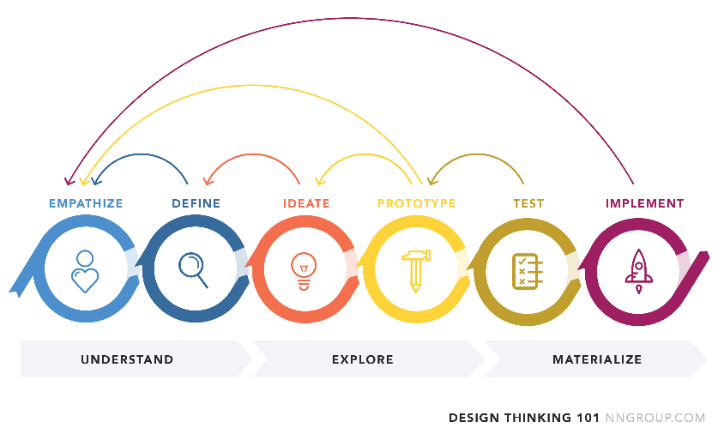
The fourth SDG Youth Summer Camp will take place in Yonsei University in Incheon, Republic of Korea and will aim to build youth leaders, with modules focusing on core skills and shaping essential mindsets for a Decade of Action. The entire process will be structured around Design Thinking to take a user-centric approach in developing accelerated solutions.

Figure SEQ Figure \* ARABIC 1. Design Thinking Methodology to Develop Accelerated Solutions in the Decade of Action
Through this methodology, youth will contribute to SDG implementation by understanding users, redefining problems and creating innovative solutions. The methodology allows participants to develop empathy, systems-thinking, and critical-thinking skills, while also developing negotiation, evaluation, advocacy, engagement and other essential leadership skills.

- Objectives
The objectives of the SDGs Youth Summer Camp will include, but are not limited to the following:
- Build and enhance knowledge of selected youth on the 2030 Agenda for Sustainable Development;
- Foster youth leadership skills, with design-thinking, critical-thinking, and engagement through dialogues and exercises on SDG implementation;
- Provide opportunities for networking among youth; and
- Expand the host institution’s partnership with youth leaders for the SDGs

- Participant Criteria
Those who are born between 1992 and 2002 are eligible to apply regardless of their nationalities by submitting application forms and supplementary documents posted on the organizers’ websites. English proficiency is required among applicants. Participants should currently be residing in the Republic of Korea.
Building on recommendations from past Youth Summer Camps, the number of participants of this year’s camp has been increased to expand inclusiveness and give more opportunities for building a larger cohort of youth leaders for the SDGs. The organizers will select a maximum of 70 participants based on their motivation, capacities and English proficiency, while ensuring gender and geographical balance.
Upon selection, the participants will be surveyed to assess interest areas under the 2030 Agenda, this will facilitate group formation during the preliminary workshop.

- Structure and Format
The Summer Camp consists of a half-day preliminary workshop in July to develop core knowledge and initiative the design-thinking process. This preliminary workshop will be followed by the three-day main camp in August.
During the preliminary workshop and three-day main camp, experts from international organizations, academia, government organizations, NGOs and the private sector will deliver their insightful ideas on the SDGs to provide key background knowledge and facilitate productive dialogues. The diversity of the speakers will ensure the Summer Camp’s overall quality and motivate participants to be fully engaged in their roles for accelerating SDG implementation.
Incheon Metropolitan City and Yonsei University, as founding partners hosting UNOSD’s office in the Republic of Korea, will also offer participants opportunities to explore concrete practices and strategies for accelerating SDG implementation. Participants will take part in a field trip to experience and learn how the Incheon Metropolitan City promotes Sustainable Development.

Stage | Date/Deadline | Subject
Inspire | ~ application | Acquire basic background knowledge of SDG through recommended media resources and readings on the SDGs and the Role of Youth in accelerating solutions for sustainable development
Preliminary Workshop
Understand & Empathise & Define | Preliminary workshop  (Half-day) | Session 1  Overview of SDGs and the Decade of Action to Accelerate progress including role of youth in key accelerators  (youth divided into groups according to key accelerators)  Session 2  Practical operational performance for Sustainable Development carried out by K-eco  Session 3  Youth leadership for Accelerating SDG implementation & Design Thinking – Youth CityPreneurs models and Case on Sustainable Consumption and Production  Session 4  Empathizing and Defining the Problem for Ideation Part I
 |  | Outcomes: Understand SDGs and role of youth; Choose key accelerators and groups to initiate design-thinking process. Gear the youth to Empathizing and Defining
Understand & Empathise & Re-define | Day 1 | Session 5  Empathizing and Defining the Problem for Ideation Part II  Session 6  Hands-on experience: a case study of SDG -incorporated solution/prototype
 |  | Outcomes: Building and testing empathy and critical-thinking skills, Groups recall pre-workshop knowledge
Ideate | Day 2 | Session 7  Ideate based on group research - Ideating for successful SDG implementation  #Group Presentation  Ideation & Faculty Feedback  Session 8  Prototyping Solutions - Prototyping for the SDGs - How?
 |  | Outcomes: Groups develop ideas to address priorities and problems
Prototype | Day 3 | Session 9  Prototyping Solutions and Testing  Session 10  Finalizing Group Presentations and Group Testing Discussions  Session 11  Innovation using Design Thinking  Session 12  Final prototyping and final pitch preparation
 |  | Outcomes: Create innovative solution; make prototype with YU students
Group Presentation | Day 4 | Final Group Presentation #1, 2  Prototype Solutions

Each session will include a group work and discussion, which will allow students to be highly interactive and encourage them to share creative ideas and critical thinking, developing a more practical approach to SDG implementation. The best awarded group/team will be invited to make a 5-minute presentation at the UNOSD Sustainable Development Transformation Forum in October 2020. All sessions in the programme will be conducted in English.

- Agenda
Preliminary Workshop – Monday, 20 July 2020
Time | Module
12:30-13:00  (30’) | Registration
13:00-13:10  (10’) | Opening Remarks
13:10-13:30  (20’) | Introduction of the programme and Organizers
13:30-14:00  (30’) | Introduction of Participants
14:00-14:40  (40’) | Session 1  Overview of SDGs and the Decade of Action to Accelerate progress including role of youth in key accelerators
14:40-15:10  (30’) | Session 2  Practical operational performance for Sustainable Development carried out by K-eco
15:10-15:50  (40’) | Session 3  Youth leadership for Accelerating SDG implementation & Design Thinking – Youth CityPreneurs models and Case on Sustainable Consumption and Production
15:50-16:00  (10’) | Break
16:00-17:00  (60’) | Session 4  Empathizing and Defining the Problem for Ideation Part I
4th SDG Youth Summer Camp
Day One - Monday, 10 August 2020
Time | Module
12:00-13:00  (60’) | Registration (ID check, name tag and package distribution)
13:00-15:50  (170’) | Design-thinking revisited - recalling the Pre-workshop lessons  Session 5  Empathizing and Defining the Problem for Ideation Part II
15:50-16:00  (10’) | Break
16:00-17:00  (60’) | Session 6  Hands-on experience: a case study of SDG -incorporated solution/prototype
18:00-20:00  (120’) | Dinner and Ice-breaking Session
Day Two - Tuesday, 11 August 2020
Time | Module
08:40-09:00  (20’) | Registration
09:00-09:15  (15’) | Opening Remarks
09:15-09:20  (5’) | Welcoming Remarks
09:20-09:40  (20’) | Outline of Course and introduction of participants
09:40-10:00  (20’) | Photo Session and Break
10:00-11:50  (110’) | Session 7  Ideate based on group research - Ideating for successful SDG implementation
11:50-12:50 | Lunch
12:50-13:50  (60’) | Session 7 – Continued  Leaving no one behind: What does it mean in the global, national and local context?
13:50-14:00  (10’) | Break
14:00-16:50  (110’) | Group Presentation  Ideation & Faculty Feedback I
16:50-17:00  (10’) | Break
17:00-17:50  (50’) | Session 8  Prototyping Solutions  - Prototyping for the SDGs - How?
17:50-19:00 | Dinner
Day Three – 12 August 2020
Time | Module
09:00-09:40  (40’) | Session 9  Prototyping Solutions and Testing  - Innovation for Sustainable Consumption and Production
09:40-10:50  (70’) | Group Discussions to refine prototyping and testing
10:50-11:00  (10’) | Break
11:00-12:00  (60’) | Session 10  Finalizing Group Presentations and Group Testing Discussions
11:50-12:50  (60’) | Lunch
12:50-14:20  (90’) | Session 11  Innovation using Design Thinking
14:20-14:30  (10’) | Break
14:30-17:50  (200’) | Session 12  Final prototyping and final pitch preparation
18:00-20:00 | Dinner Reception
Day Four, 13 August, 2020
Time | Module
09:00-10:00  (60’) | Final Group Presentation #1  Prototype Solutions
10:00-10:10  (10’) | Break
10:10-11:10  (60’) | Final Group Presentation #2  Prototype Solutions
11:10-12:00  (50’) | Awards Ceremony / Closing Remarks
12:00-13:00 | Lunch
13:00-15:00 | Field trip

- Schedule and Venue*
The event consists of one half-day preliminary workshop and the four-day main summer camp. The pre-workshop will take place on 20 July 2020 at the Korea Environment Corporation Yeouido Training Office in Seoul.
The main 4th SDG Youth Summer Camp will take place 10-13 August 2020* at the Yonsei University International College, Incheon, Republic of Korea.
* The dates and venue of Youth Summer Camp are subject to change based on assessment of COVID-19 situation in Republic of Korea by national, local and Yonsei University authorities as well as by the UNHQ in New York.

- Organizers
The 4th SDG Youth Summer Camp is organized by UNOSD and K-eco, in partnership with Yonsei University.

- Outputs
The youth camp will produce two primary outputs. They include:
- Increased knowledge, skills and mindsets for accelerating solutions to implement the SDGs; and
- A short report on the camp with recommendations for future camps.

- Contact
Mr. Jean D’Aragon, Officer-in Charge, UNOSD
Email: daragon@un.org
Tel.: +82 (32) 822 9088
Ms. Sara Castro-Hallgren, Ms. Youngeun Choi, Ms. Ilae Kim, Mr. Huiyong Kim, UNOSD
Email: sara.castrohallgren@un.org, youngeun.choi@un.org, kim23@un.org, hui.kim@un.org
Tel.: +82 (32) 822 9091, +82 (32) 822 9083

United Nations, 2019. Retrieved from: https://www.un.org/sustainabledevelopment/youth/
United Nations, 2019. Retrieved from: https://www.un.org/sustainabledevelopment/youth/
United Nations, 2020. Retrieved from: https://www.un.org/sg/en/content/sg/speeches/2020-01-22/remarks-general-assembly-priorities-for-2020
Greta Thunberg is a Swedish climate activist who began her movement for climate action at the age of 15. For more information see: www.FridaysforFuture.org
For example, see https://www.un.org/sustainabledevelopment/be-the-change/
UNOSD has organized three Summer Camps thus far, with the following number of participants per session, 2017 included 56 youth participants, 2018 included 51 youth participants, and 2019 included 52 youth participants. In total, 159 youth participants were trained through these events.

